Low Level Design

**HR Analytics - Turnover**

|  |  |
| --- | --- |
| **Written By** | Pawan Nagar |
| **Document Version** | 1.0 |
| **Last Revised Date** | 31-03-2023 |

# DOCUMENT CONTROL

**Change Record:**

|  |  |  |  |
| --- | --- | --- | --- |
| **VERSION** | **DATE** | **AUTHOR** | **COMMENTS** |
| 0.1 | 20- March-  2023 | Pawan Nagar | Introduction |
| 0.2 | 21- March-  2023 | Pawan Nagar | Architecture defined |
| 0.3 | 22- March-  2023 | Pawan Nagar | Power Bi Server Architecture |
| 0.4 | 24- March-  2023 | Pawan Nagar | Architecture Description |
| 0.5 | 25- March-  2023 | Pawan Nagar | Deployment |
| 1.0 | 31- March-  2023 | Pawan Nagar | Done |

**Reviews:**

|  |  |  |  |  |  |  |  |  |
| --- | --- | --- | --- | --- | --- | --- | --- | --- |
| **VERSION** | **DATE** |  | **REVIEWER** |  | **COMMENTS** | | |  |
|  |  |  |  |  |  | | |  |
| **Approval Status:** | |  |  |  |  | | |  |
| **VERSION** | **REVIEW DATE** |  | **REVIEWED BY** |  |  | **APPROVED BY** |  | **COMMENTS** |
|  |  |  | |  | |  |  | |

# Contents

## 1. Introduction………………………………………………………………………………………………………… 04

**1.1 What is Low-Level Design Document? ……….……………………………………………….. 04 1.2 Scope ………………………………………………….……………………………………………………... 04**

## 2. Architecture ………………………………………………………………………………………………………. 05

## 3. Architecture Description ………………………………………………………………………………….…07

**3.1 Data Description ……………………………………………………………………………………….… 07**

**3.2 Web Scrapping ………………………………………………………………………………………….… 07**

**3.3 Data Transformation …………………………………………………………………………………... 07**

**3.4 Data insertion into database ………………………………………………………………………. 08**

**3.5 Export Data from database ………………………………………………………………….….…..12**

**3.6 Deployment …………………………………………………………………………………………….……12**

**3. Unit Test Cases ……………………………………………………………………………………………….…12**

# 1. Introduction

**1.1 What is Low-Level design document?**

The goal of the LDD or Low-level design document (LLDD) is to give the internal logic design of the actual program code for the House Price Prediction dashboard. LDD describes the class diagrams with the methods and relations between classes and programs specs. It describes the modules so that the programmer can directly code the program from the document.

## 1.2 Scope

Low-level design (LLD) is a component-level design process that follows a step-by-step refinement process. The process can be used for designing data structures, required software architecture, source code and ultimately, performance algorithms. Overall, the data organization may be defined during requirement analysis and then refined during data design work.

# 2. Architecture

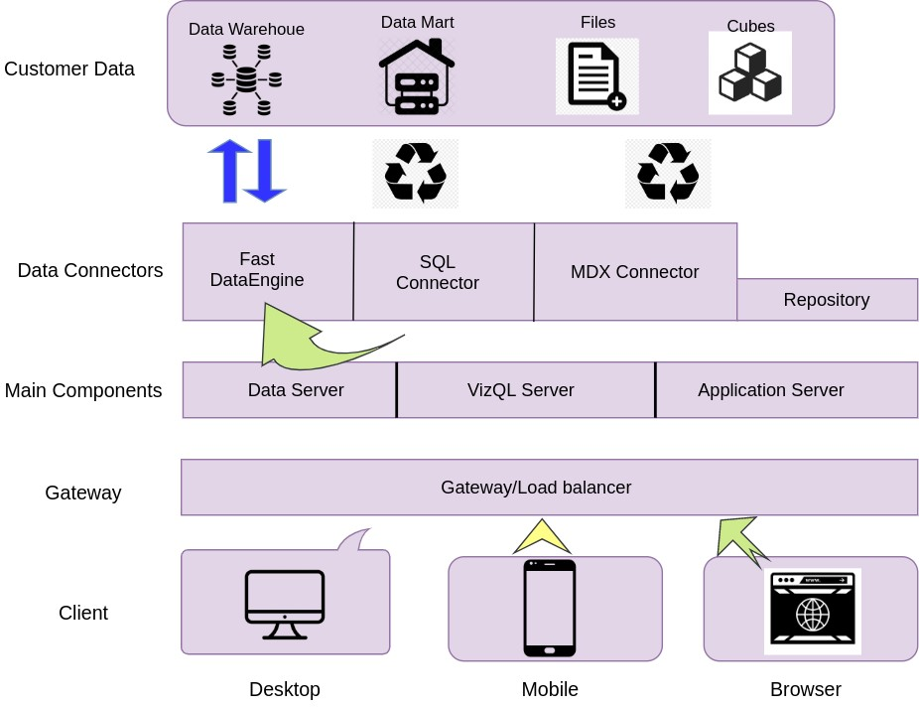

# Power Bi Server Architecture

|  |  |
| --- | --- |
| Power BI is a business suite that includes several technologies that work together. To deliver outstanding business intelligence solutions, Microsoft Power BI technology consists of a group of components such as:   * Power Query (for data mash-up and transformation) * Power BI Desktop (a companion development tool) * Power BI Mobile (for Android, iOS, Windows phones) * Power Pivot (for in-memory tabular data modelling) * Power View (for viewing data visualizations) * Power Map (for visualizing 3D geo-spatial data) * Power Q&A (for natural language Q&A) | |
| The following diagram shows Power bi Server’s architecture  : |  |

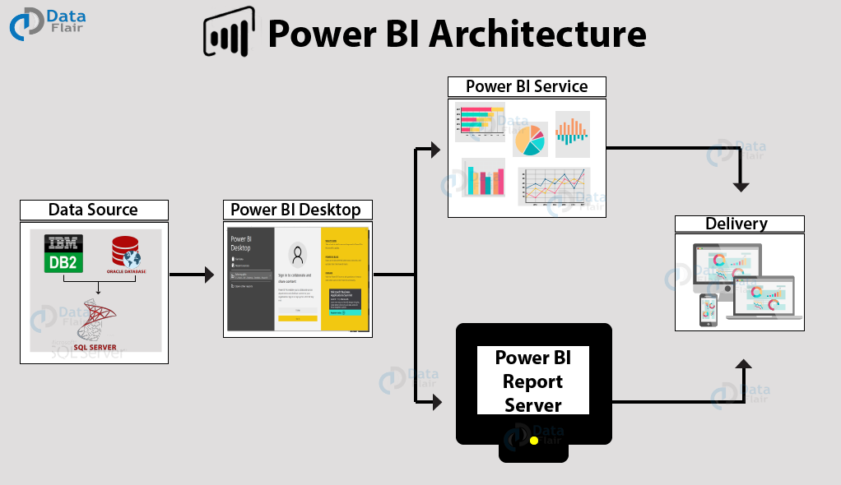

Power bi Server is internally managed by the multiple server processes.

## Data Source

## An important component of Power BI is its vast range of data sources. You can import data from files in your system, cloud-based online data sources or connect directly to live connections.

* Excel
* Text/CSV
* XML
* JSON
* Oracle Database
* IBM DB2 Database
* MySQL Database
* PostgreSQL Database
* Sybase Database
* Teradata Database
* SAP HANA Database
* SAP Business Warehouse server
* Amazon Redshift
* Impala
* Google Big Query (Beta)
* Azure SQL Database
* Salesforce Reports
* Google Analytics
* Facebook
* GitHub

## 2) Power BI Desktop: -

Power BI Desktop is a client-side tool known as a companion development and authoring tool.

This desktop-based software is loaded with tools and functionalities to connect to data sources, transform data, data modelling and creating reports.

You can download and install Power BI Desktop in your system for free. Using Power BI Desktop features, one can do data cleansing, create business metrics and data models, define the relationship between data, define hierarchies, create visuals and publish reports.

## 3) Power BI Service: -

Power BI Service is a web-based platform from where you can share reports made on Power BI Desktop, collaborate with other users, and create dashboards.

* Free version
* Pro version
* Premium version

Power BI Service is also known as, **“Power BI.com”**, **“Power BI Workspace”**, **“Power BI Site”** and **“Power BI Web Portal”**. This component also offers advanced features like natural language Q&A and alerts.

## 4) Power BI Report Server: -

The Power BI Report Server is similar to the Power BI Service. The only difference between these two is that Power BI Report Server is an on premise platform. It is used by organizations who do not want to publish their reports on the cloud and are concerned about the security of their data.

Power BI Report Server enables you to create dashboards and share your reports with other users following proper security protocols. To use this service, you need to have a Power BI Premium license.

# 3. Architecture Description

Power BI is a collection of software services, apps, and connectors that work together to turn your unrelated sources of data into coherent, visually immersive, and interactive insights. Your data might be an Excel spreadsheet, or a collection of cloud-based and on-premises hybrid data warehouses.

## 3.1. Data Description

To help members of your organization quickly identify datasets that might be useful for them, provide a concise, informative description of your dataset in the dataset's settings. Users see this description in the tooltip next to the dataset's name in the datasets hub and on the dataset's details page.

Providing a meaningful description helps foster dataset reuse. For instance, based on a dataset's description, users may decide to explore reports that are based on the dataset, or to create their own reports based on the dataset.

## 3.2. Web Scrapping

Web scraping is a technique to automatically extract content and data from websites using bots. It is also known as web data extraction or web harvesting. Web scrapping is made simple now days, many tools are used for web scrapping. Some of python libraries used for web scrapping are Beautiful Soup, Scrapy, Selenium, etc.

## 3.3. Data Transformation

In the Transformation Process, we will convert our original datasets with other necessary attributes format. And will merge it with the Scrapped dataset.

## 3.4. Data Insertion into Database

Power BI Transform Data :-

Clean and Load Data in Power Query 2023. Data comes in an unformatted structure, and it requires a skill set to format the data and extract valuable insights from it.

* Power BI Desktop
* Power Query Editor
* Power BI Transform
* Data Import Data
* Changing Table
* Name Remove
* First Row
* Replace Null Value
* Remove Unnecessary
* Rows Rename
* Column Headings
* Separating Columns
* Merge Columns
* Unpivot the Columns
* Change Data
* Type Append Queries
* Conditional Column

**3.5 Deployment.**

The deployment process lets you clone content from one stage in the deployment pipeline to another, typically from development to test, and from test to production. During deployment, Power BI copies the content from the current stage, into the target one

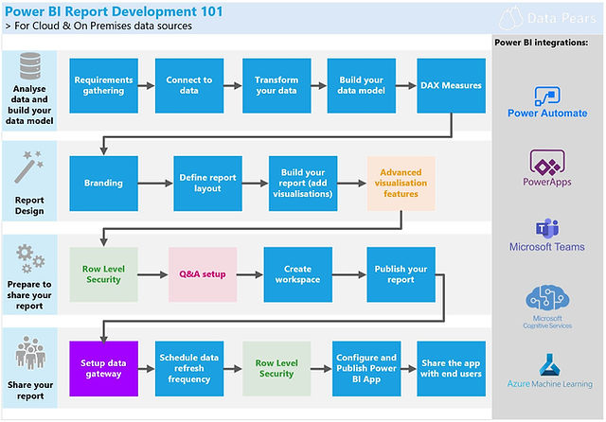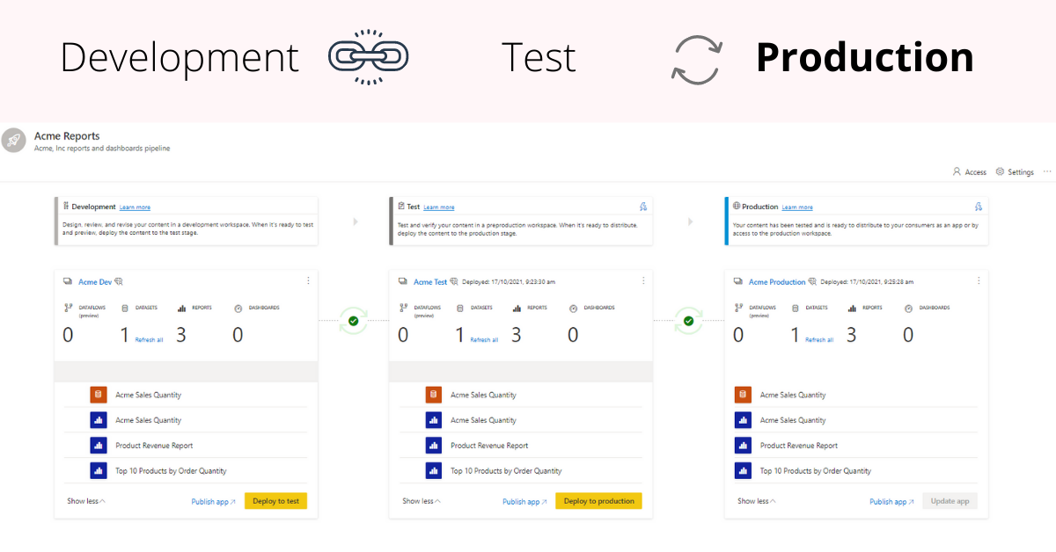.

We should be able to address these questions satisfactorily for a successful sales pitch. To answer these questions, we should be aware of the deployment models of Power BI. In this blog let us go through these aspects of Power BI.

We need to first understand generic deployment models

* **On-Premises:**

Refers to data, applications and infrastructure entirely owned by client at client data centre and client has complete control over it.

* **Cloud:**

Refers to data, infrastructure and/or services residing in a public cloud environment and completely managed /controlled by third party. Microsoft Azure and web based Power BI service are examples of the cloud offerings.

* **Hybrid:**
* This denotes to the implementation which spans both on premises and cloud sources which can be services, infrastructure and data sources
* Power BI supports all three types of models. Let us see how this is possible and exactly what is to be done.
* **On-Premises Deployment:**

Power BI can be deployed on premise three different options. Kindly refer below diagram.

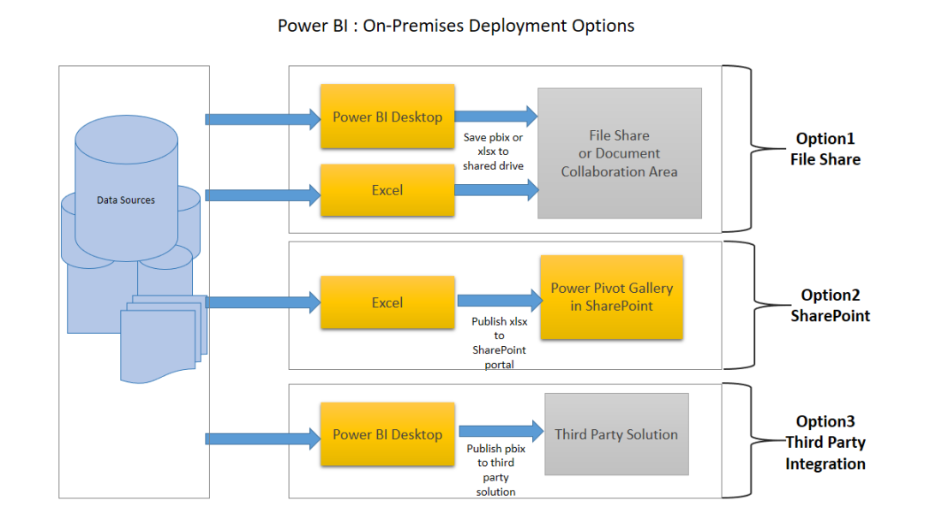

**Option 1: File Share**

* The first on-premises option involves usage of a file share: Data preparation and report creation is done in client tools: Power BI Desktop and/or Excel.
* The completed Power BI Desktop and/or Excel file is published to a file share or a document collaboration area / repository.
* To view the reports, Excel or Power BI desktop has to be installed on the viewer’s machine

**Option 2: SharePoint**

The second on-premises option involves a specialized document library in SharePoint called the Power Pivot Gallery. Due to my limited knowledge, I am not going in details of this option

* Data preparation and report creation occurs in Excel.
* The completed Excel file is published to SharePoint within a Power Pivot Gallery.

**Option 3: Third Party Integration**

The third on-premises option involves a third party which integrates with Power BI.

* Data preparation and report creation occurs in Power BI Desktop.
* The completed Power BI Desktop file is published to the third party server

**Hybrid Deployment**

Power BI can be deployed in hybrid mode in three different options. Kindly refer below diagram.

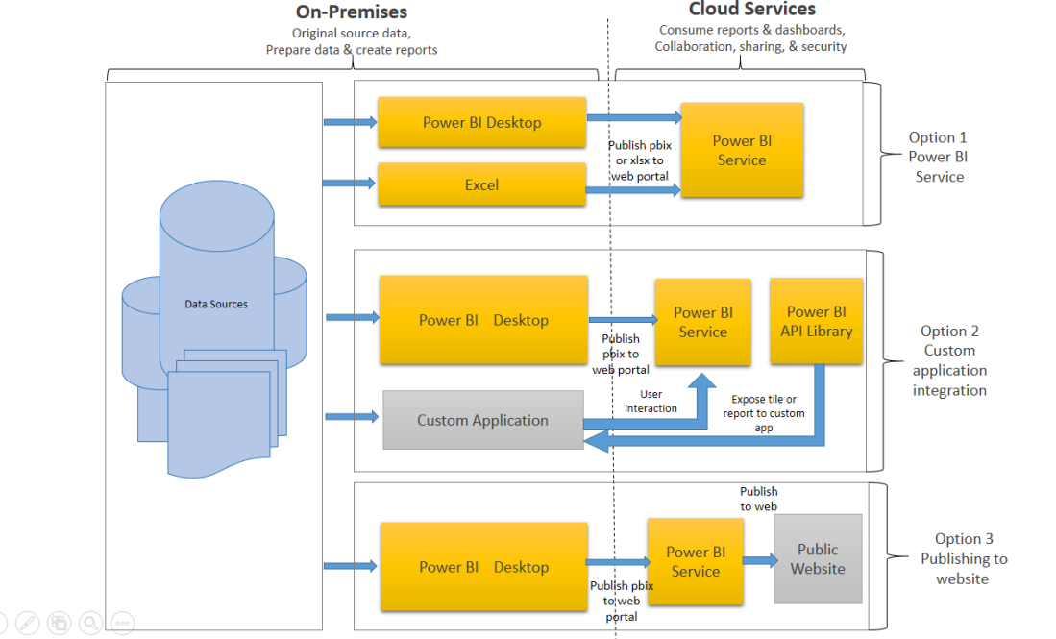

**Option 1: Power BI Service**

* Data is either from the on premises corporate applications or it might be born in cloud. It can even mix of these two
* Data preparation and report creation occurs in Power BI Desktop or excel
* Completed Power BI reports are then published to Power BI service
* Report consumption, sharing, security, collaboration, data refresh happens in Power BI service
* Dashboards are created in Power BI service and reports can also be edited or created in Power BI service

**Option 2: Custom Application Integration**

* Data is either from the on premises corporate applications or it might be born in cloud. It can even mix of these two
* Data preparation and report creation occurs in Power BI Desktop
* Completed Power BI reports are then published to Power BI service
* An embed code is generated by Power BI service for selected report and this code can be embedded in web page of the website within iFrame
* Here no security is maintained as its public website, hence suitable for the data which can be made publicly available

# 4. Unit Test Cases

|  |  |
| --- | --- |
| **TEST CASE DESCRIPTION** | **EXPECTED RESULTS** |
| **Tiles for Quick Analysis:** | Tiles Should Provide the clear shot of one key data about that particular field. |
| **Filters of Dashboard** | Filters should provide the broader analysis of data in different-different combinations. |
| **Gender Based Analysis Visuals** | Gender based Analysis Tiles Should provide all analytics which is depending on Gender along with the filters. |
| **Industry Based Analysis Visuals** | Industry based Analysis Tiles Should provide all analytics which is depending on Industry along with the filters. |